# Gaming Data Sales Analysis Project Report

## I. Introduction

- The propose: Our group’s focus for this project is to deliver meaningful insights from gaming sales data along with market information on the prospect of Health & Fitness video games. We believe this will help to support RedBack Operation’s development direction and allow our board of directors to make more informed decisions. Games are one of the easiest forms of entertainment to get people engaged as they usually bring out excitement. If we can capitalize on incorporating exercises into video games, we can encourage self-healthcare and increase awareness in fitness.

- Questions to be answered and goals: What does the gaming sales data from the past years suggest? Is there a rise in sales of the whole Fitness & Health genre? Is there a particular game that stood out in this category? How much is the growth and what can we expect from the upcoming years? What is the overall trend of the gaming industry now? Are there other sources of information that will help prove the marketability of Health & Fitness games? In summary, we would like to see if there is sufficient room for development and growth in this category and the financial prospect of it.

- Techniques and languages used: In this project, we will mainly be using Python for data cleaning, processing and analysis with the use of science libraries such as seaborn, matplotlib and NumPy. For the visualization aspect, the aforementioned libraries like seaborn and matplotlib are both suitable for producing insightful graphs and charts. Furthermore, we will use Tableau with the cleaned dataset to produce more visual representations of our analysis.

- Limitations: The biggest drawback we can clearly notice at this moment is the availability of data for us to provide an in-depth analysis regarding this topic. It is fair to say that the current volume and scope of our data is not enough to provide insights that are representative of the market and growth of Health & Fitness video games. Furthermore, we have yet to fully explore a major market – which is the mobile gaming industry – thus this could potentially be the future target to analyze and research on.

## II. Analyzing the data

**2019 -** Game Sales/Total Shipping/Critic Scores Analysis for Genre’s like Sports, Simulation & Roleplaying to visualize the market for our company. (Gouri Nandan)

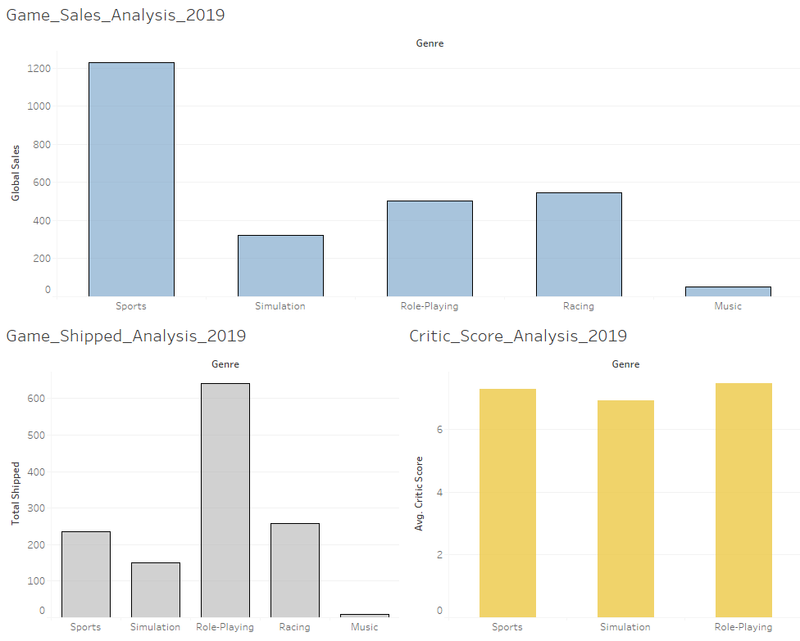

* VR games sales on Steam analysis

As one of the biggest gaming platforms, many publishers choose to release games on the Steam. We’ve counted the number of VR games releases in each year. In 2016, VR games on the Steam platform showed explosive growth, about 14.4 times than the number of VR games in 2014. After that, the trend slowly declined until 2019, and then stabilizes.

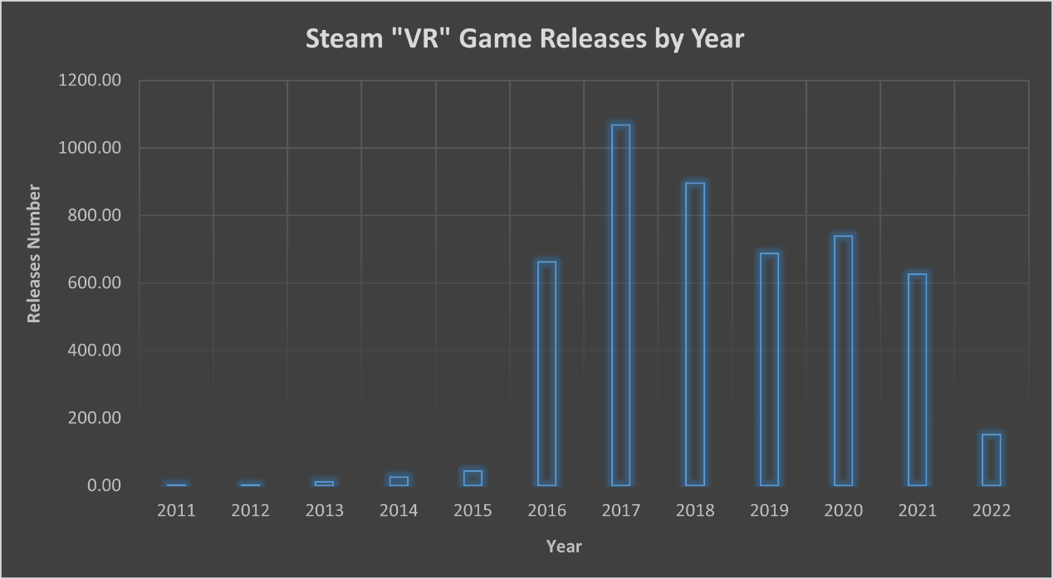

As can be seen from the sales of the top ten VR games on the Steam platform, the overall sales of VR games still have a lot of room for growth. According to the sales data, the promotion, sociality, and technology of the game have great impacts on the sales of the game. For example, on Twitch and YouTube, there are a lot of Phasmophobia game live videos and recommendations; Beat Saber has set up a party mode and an online player battle mode; and Half-Life: Alyx has advanced technology and targeted optimized VR support.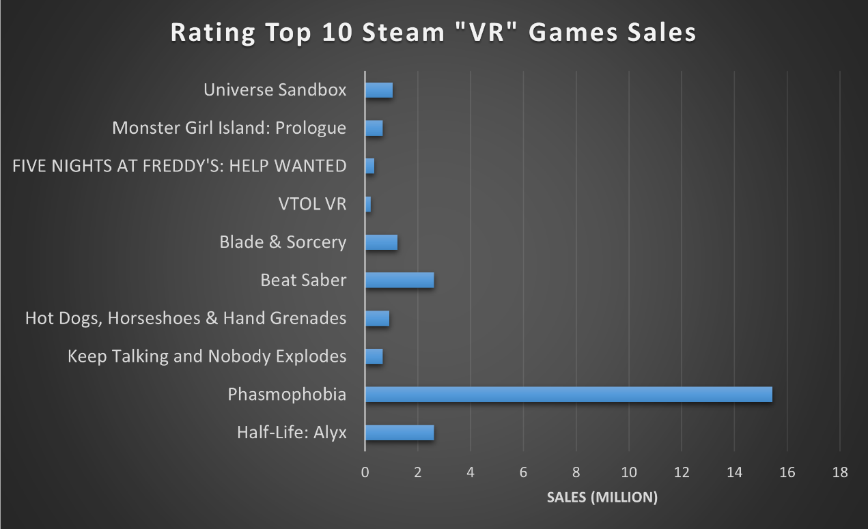

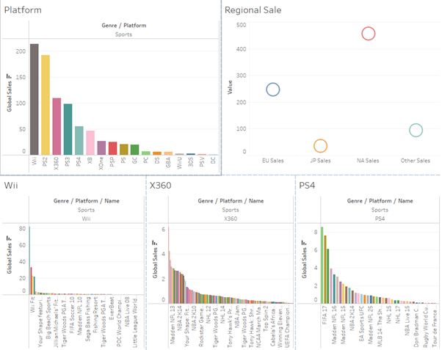  
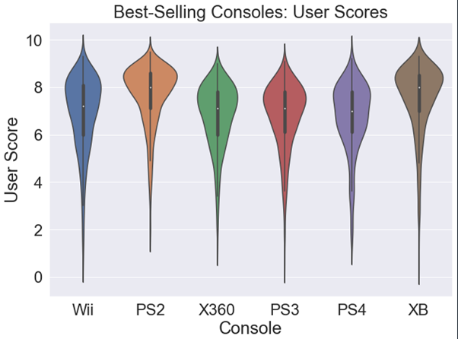

- According to the figures of regional sales’ figure over three period of times (from 2016 to 2019), sales in North America stably stand the highest and climb gradually from 450 to 650 in 2019 in the sport genre. In terms of consoles’ popularity, PS2 and XB get 1 point higher score on average comparing to all other platforms. However global sales suggest that Wii and PS2 still dominate in games related to sport, with North America taking up more than 40% of total sales. It can be seen that sport games featuring soccer, American football and basketball are among the top choice for players regardless of regions - which suggests a possibility for tackling gamers.

- Since the project is a start-up firm scale it is crucial to take feasibility in both cost efficiency and potential growth of a region in consideration. EU sales figure suggest a possible cost-saving investment option and lower risk comparing to demanding market such as NA where competitors might be more fierce

## III. Marketability of Fitness & Health games

### a. Market Value and Opportunities

- In recent years, there have been major strides in the development of video games and entertainment in general, attracting millions more to enjoy various diverse form of digital content. Notably, according to NewZoo’s report (2021, p.23):

+ The total number of gamers globally saw an increase of nearly 1 billion from 2015 to 2021.

+ In the next few years, the tally of players from around the word is expected to increase by 12% from 2021 to 2024, which equates to over 300 million more players.

+ Overall, the general statistics suggest a steady increase of consumers for video games, making the gaming industry one of the most stable-growing market.

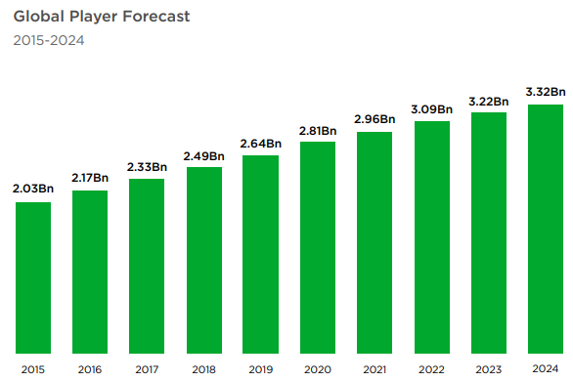

- Seeing how lucrative the possible opportunities in the gaming industry can be, we should take a closer look at how the pie was divided for each segment (NewZoo, p. 20):

+ Overall, we saw a minor decrease of 1 percent compared to 2020 in terms of market value. However, this is still a market that was approximately estimated at 175.8 billion dollars.

+ Console and PC games are still 2 major parts of this industry and there have been many Health & Fitness games saw ludicrous success in these platforms.

+ Surprisingly, mobile games became the biggest player, overtaking nearly half of the market and it is one of the least engaged in terms of Health & Fitness games due to limited implementations and the existing of similarly goaled Fitness apps – another diverse market with huge usage of IoT devices.

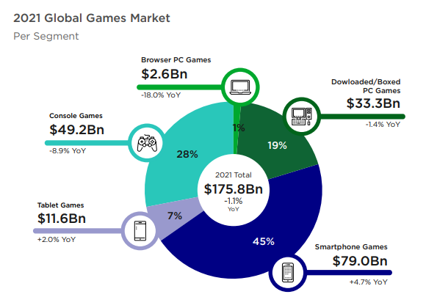

- Swain and Ugalmugle (2021, pp. 57-120) summarized the forecast of Healthcare gamification market by 2027 as followed:

+ In 2020, the rise in awareness for maintaining a healthy lifestyle along with the rise of demands for exercising had helped the Fitness apps and games to overtook 51% of the market – this does include not just video games but has showed tremendous potential for this segment as a whole.

+ Gamification of exercise games is expected to almost triple by 2027, making it the most anticipated leap in terms of growth.

+ All parts of the world showed positive reception of the trend towards fitness and lifestyle gamification as users’ awareness rose significantly. The North America market is forecasted to be the major leader in the designated timeline.

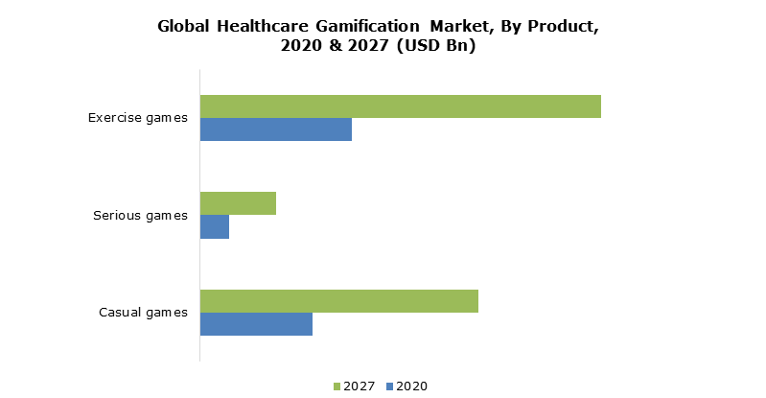

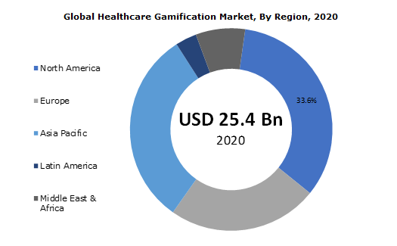

- Moving into the VR gaming section as it boasts one of the most practical implementation to fuel gamers’ desire to burn calories and experience enjoyable exercises, Alsop (2022) and Fortune Business Insights (2021) reported:

+ Fortune Business Insights expected a Compound Annual Growth Rate (CAGR) of over 44.8% from 2021 to 2028 for the VR industry, this includes all implementation of VR not just related to Health & Fitness in general but we can also see the overall potential of VR as treadmills, gloves, simulators and other devices equate to more than half of VR implementaion in 2020.

+ Alsop predicted a triple growth in market value for this segment by 2024, suggesting a steady but significant annual increase.

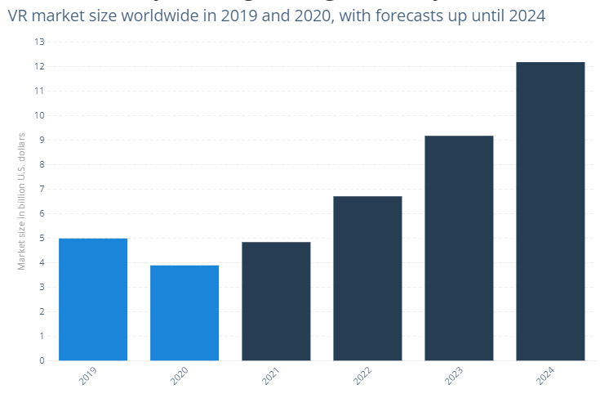

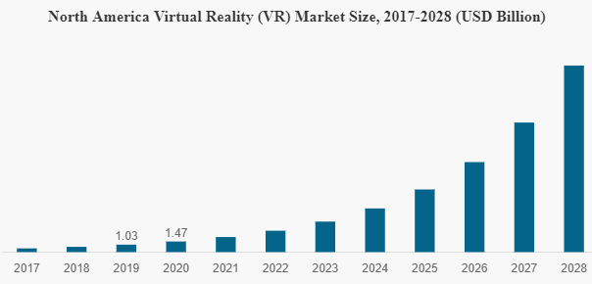

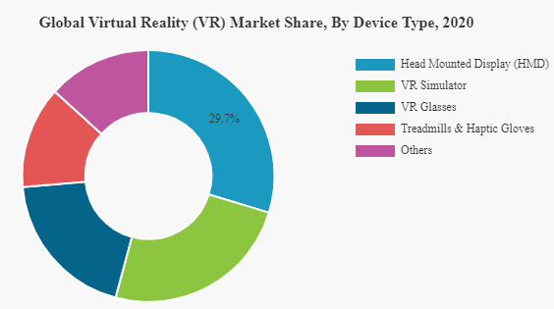

b. Success Of Early Developers

- According to Nintendo’s Financial Report for 2021, Ring Fit Adventure managed to finish in their top 10 best-selling video games, totaling up to over 13.5 million units sold (Nintendo 2022, p. 16). In the period from April 2021 to December 2021, the game sold a whopping 3.42 million copies – which indicated a rise in interest considering after this period the game was 4 years old (Nintendo 2022, p. 16).

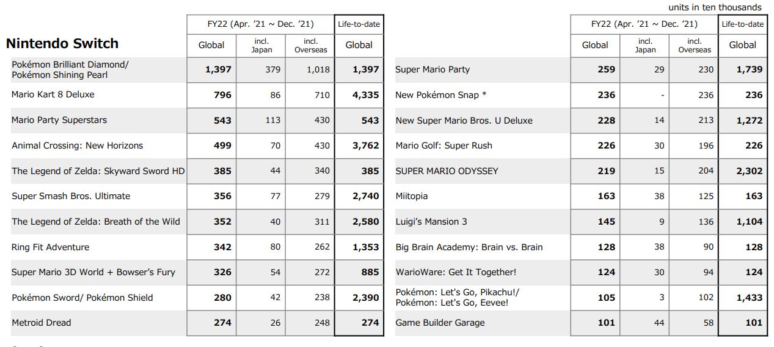

- For veteran titles in the fitness section, Just Dance by Ubisoft announced total life-time sales of over 80 million copies (Ubisoft 2022). Additionally, Ubisoft (2022) expected Just Dance to rival the rise of Nintendo’s fitness titles and leverage the success of Switch devices.

- Beat Saber and its creator Oculus, acquired by Meta in 2014, also saw moderate success in the VR realm. Recently, Verdu, VP of Content for Oculus, (2021) reported that 4 million Beat Saber titles were sold while accumulating more than 40 million paid DLC songs. This had pushed the estimated revenue to over 180 million dollars – with an average of roughly 27 dollars per copy and 1.75 dollars per song.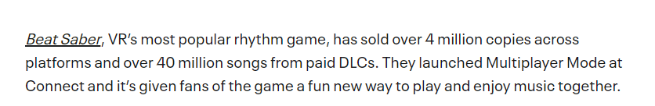

c. Recommendations

- For addressing the limitations of this research/analysis, the most glaring issues is the lack of sufficient data that is representative of our clientele. Hence, here are some of our suggestions:

+ Invest in getting real market reports from reputable sources that go into details on how segmented the industry is.

+ Research for better data sources in order to produce better and more centralized analysis.

+ Narrow down our target audience for future projects so we can focus on statistics of that specific range of customers/potential users.

+ Utilize more advanced scraping techniques to get more insightful data – in this case the source of our data varied a lot and scraping was not really a valid option.

d. References:

1) Newzoo (2021) *Global Games Market Report: The VR & Metaverse Edition*, Newzoo, accessed 21st March 2022.

<https://resources.newzoo.com/hubfs/Reports/2021_Free_Global_Games_Market_Report.pdf?utm_campaign=GGMR%202021&utm_medium=email&_hsmi=137510824&_hsenc=p2ANqtz-_m450_L9g5cNsGt5GnkK8E-7E9lL7yyoNsERTDScrhqPhuGZWsmG1ODKnI3tmxKGHXR1RStxvYcldmWWMKQKM1YXc3rQ&utm_content=137510824&utm_source=hs_automation>

2) Nintendo Co., Ltd (2022) *Financial Results Explanatory Materials: 3rd Quarter of Fiscal Year Ending March 2022*, accessed 23rd March 2022.

<https://www.nintendo.co.jp/ir/pdf/2022/220203_3e.pdf>

3) Sumant Ugalmugle & Rupali Swain (2021) *Healthcare Gamification Market Size By Game Type (Casual Games, Serious Games, Exercise Games), By Application (Prevention, Therapeutic, Education), By End-Use (Enterprise Based, Consumer Based), COVID19 Impact Analysis, Regional Outlook, Application Potential, Price Trends, Competitive Market Share & Forecast, 2021 – 2027*, Global Market Insights, accessed 21st March 2022.

<https://www.gminsights.com/industry-analysis/healthcare-gamification-market>

4) Thomas Alsop (2022), *Virtual reality (VR) - statistics & facts*, Statista, accessed 23rd March 2022.

<https://www.statista.com/topics/2532/virtual-reality-vr/#dossierKeyfigures>

5) Meta (2022), *Meta Reports Fourth Quarter and Full Year 2021 Results*, Meta, accessed 22nd March 2022.

<https://investor.fb.com/investor-news/press-release-details/2022/Meta-Reports-Fourth-Quarter-and-Full-Year-2021-Results/default.aspx>

6) Mike Verdu (Feb 2 2021) *From beat to bull: How Oculus Quest 2 is changing the game for VR*, Meta Quest, accessed 20th March 2022.

<https://www.oculus.com/blog/from-bear-to-bull-how-oculus-quest-2-is-changing-the-game-for-vr/>

7) Fortune Business Insights (2021) *The global virtual reality market is projected to grow from $6.30 billion in 2021 to $84.09 billion in 2028 at a CAGR of 44.8% in the forecast period, 2021-2028, Fortune Business Insights*, accessed 20th March 2022.

<https://www.fortunebusinessinsights.com/industry-reports/virtual-reality-market-101378>

8) Ubisoft (2022) UBISOFT REPORTS THIRD-QUARTER 2021-22 SALES, Ubisoft, accessed 24th March 2022.

<https://staticctf.akamaized.net/8aefmxkxpxwl/4ZA5JuOKbheerHwUS1ugBQ/aa27c309863ce1b4ef7abbae6c631739/Ubisoft_FY22_Q3_sales_PR_English_vf.pdf>